*AAST CCIT – Introduction to Problem Solving and Programming (CS143)*

**7th Week Project**

Name: Yara Hesham Mohammed Abdallah ELMowafy

RegID: 19100910

Class: f

TA: Eng,Mahmoud Elasayad

* + *An explanation of why I chose this type of data structure:*

I choose 2d-array as

1: I want to display data in 2 dimensions one of the company branches and the other for months of each branch

2:It is flexible to make operations like addition and deletion on it.

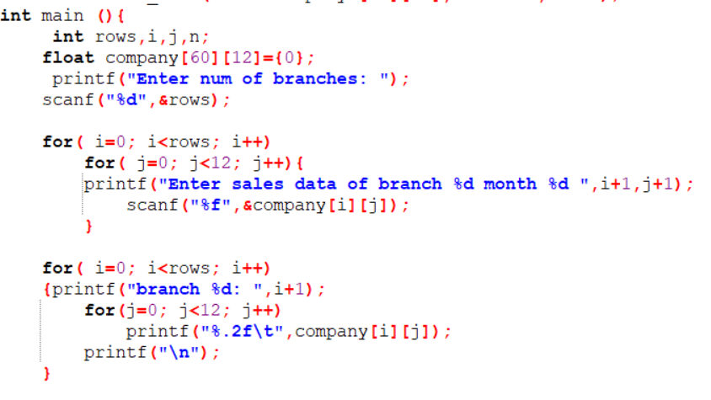 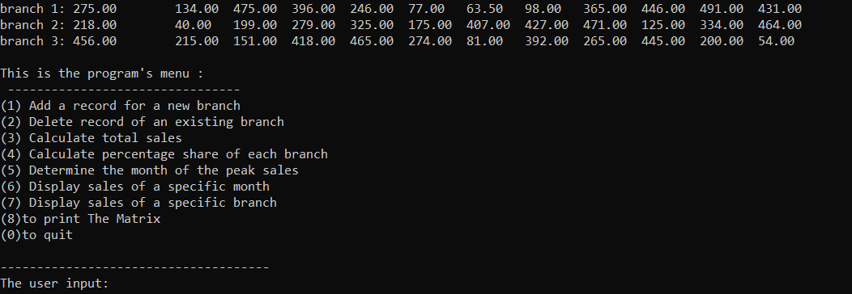

* + ***Functions :***

***(first)Enter data***

* *I asked the user to enter the number of branches*
* *The first 2 foor loops the outer one to loop the number of branches that the user entered the inner one to loop 12 months of each branch and take slaes data from user*
* *The second 2 for loops the outer one to loop the number of branches that the user entered the inner one to loop 12 months of each branch and display the matrix with the sales data*

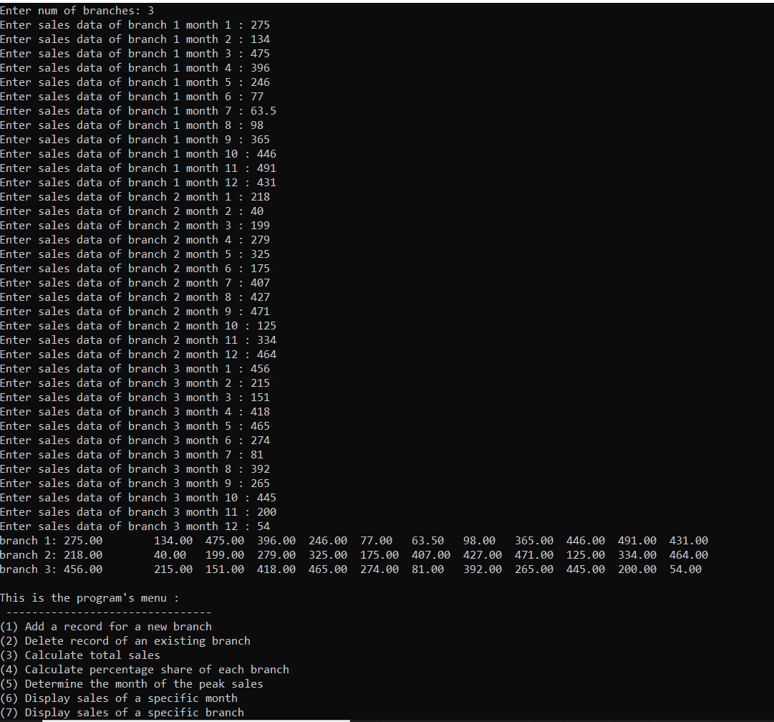

***(then)MENU:***

* *{9} MESSAGES for the user to understand how to use the program*

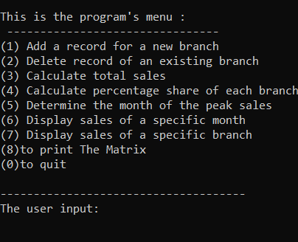

* ***Finnaly the menu’s functions***

***(1)add function:***

* *I made this function to add new branch*
* *First I fill array with 0s to have many empty rows.*
* *I made the first for loop to know the first empty row which has {,0,0,0,0,0,0,….} so it will be the new row .*
* *The second for loop to enter sales data in the new branch.*
* 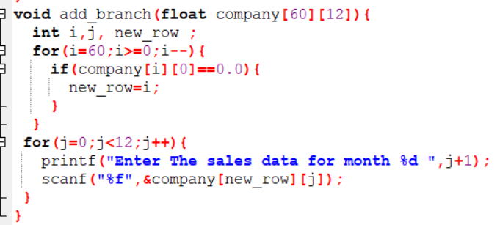

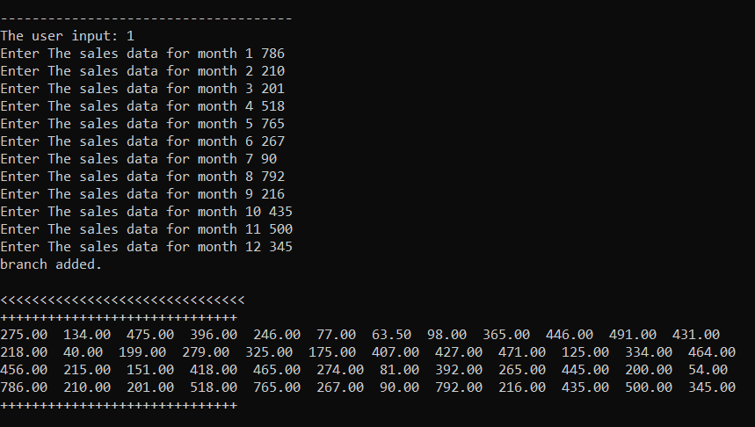

***(2)delete function:***

* *To delete a branch from the company.*
* *I asked the user to give the number of the branch to be deleted.*
* *I fill this branch whith 0s .*
* *Print the array without 0s.*

***before***

* 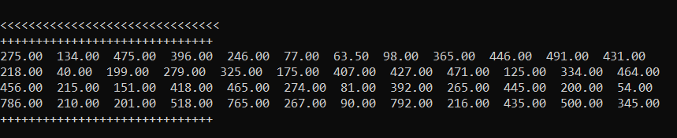

***after***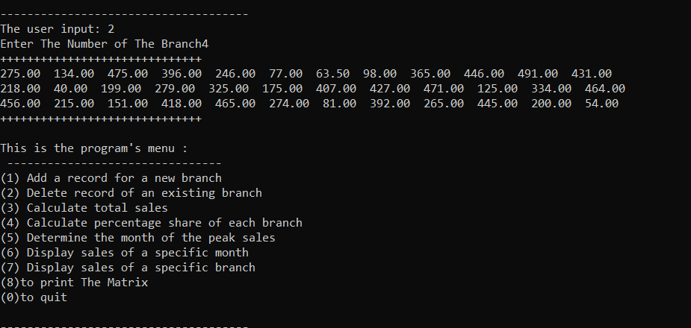

***(3) total sales function***

* *I made 2for loops one to loop branches the other to loop monthes*
* *And it give the sum of all the elemnts and return total sum.*

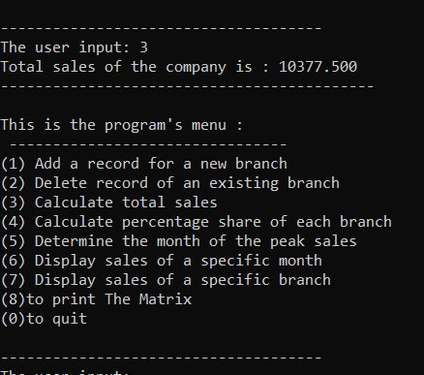

***(4)percentage share of each branch:***

***To*** *Calculate the percentage share of each branch in the total sales*

* *I used the same total sales function to have the total*
* *Secondly,I made 2 for loops the outer to loop branches and the inner one to loop months of each branch and return the sum of each branch*
* *Finally the percentage of each branch = (sum of that branch/totalsales)*100*
* 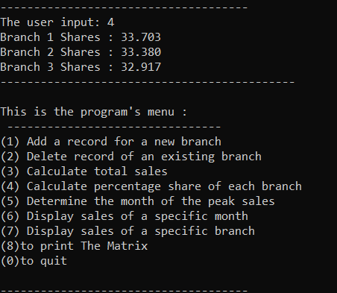

***(5)The peak sales month***

***To*** *Determine the month of the peak sales.*

* *I sit maxi =-9999999, M_SUM=0*
* *I Made 2 for loops the outer to loop months(each column)the inner to loop branches of each month(each element in the column)and give the sum of each column then compare it with the others*
* *IF M_SUM (SUM OF THE MONTH)>MAXI*

*Make maxi =M_SUM*

*then print the maxi as the peeak sale,flag+1 =the index of the peak month* 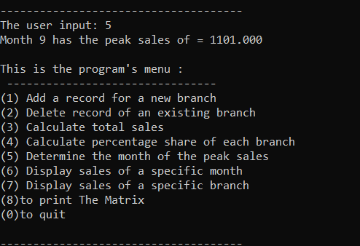

tt

***(6)bubble sorting function***

***To*** *Allows the user to specify a certain month, and in response the program displays the list of branch indices sorted in a descending order based on the sales revenue*

* *[FIRST ] I made a copy of the array because I didn’t need to make changes in the original array*
* *Then . I made 2 for loops the outer to loop numbers of processes (num of branches -1) I want to do in the month the inner to loop elements of column*
* *If condition to knew if the first element (branch) is less than the second one if it true it will swap them*
* *Finally for loop to print the new column with the correct sort*
* *n is the index of the month which should be sorted*

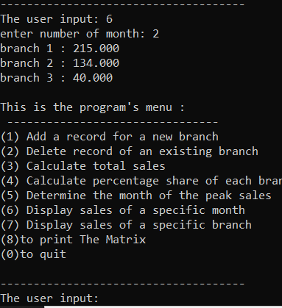

***(7)selection sort function***

***To*** *Allows the user to specify a certain branch, and in response the program displays the list of months indices sorted in a descending order based on the sales revenue.*

to

* *[FIRST ] I made a copy of the array because I didn’t need to make changes in the original array*
* *Then . I made 2 for loops the outer to loop numbers of processes I want to do in the branch the inner to loop elements of row*
* *If condition to knew if the second element (branch) is bigger than the first one if it true it will swap them*
* *Finally for loop to print the new row( branch) with the correct sort*
* *n is the index of the branch which should be sorted*

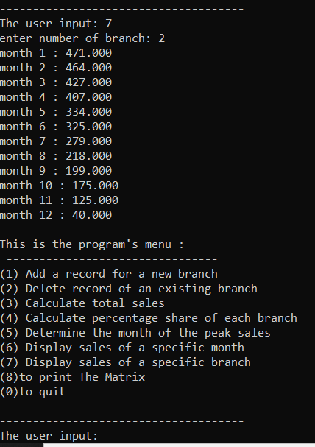

***(8) print matrix***

***I mad this function to view the changes and to call it after each function***

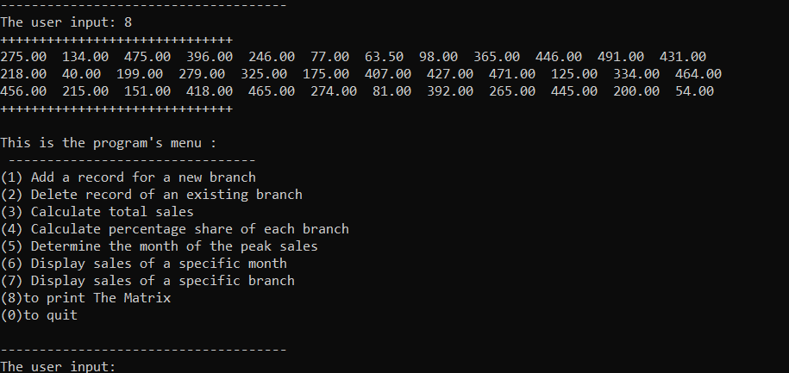

***(0)to end the program***

